Metro Ticket Generating System in ServiceNow
Phase 3: UI/UX Development & Customization
Item | Details
Project | Metro Ticket Generating System in ServiceNow
Phase | Phase 3: UI/UX Development & Customization
Platform | ServiceNow
Prepared by | Bharath Chowdary Tammineedi
Status | In Progress

1. Phase Overview
This phase designs user-friendly interfaces and customizes layouts to enhance usability and brand consistency. It covers the interface design of the Book A Metro Ticket service catalog item and its variables, and the portal widget that shows the QR code ticket.

2. Interface Design

2.1 Activity 1: Creation of Service Catalog Item
- Open the Application Navigator.
- Click All and search for Service Catalog.
- Under Service Catalog, click Maintain Items.
- Click New.
- Fill in the details as shown below.
- Fill in the Short Description, if required.
- Click Save.
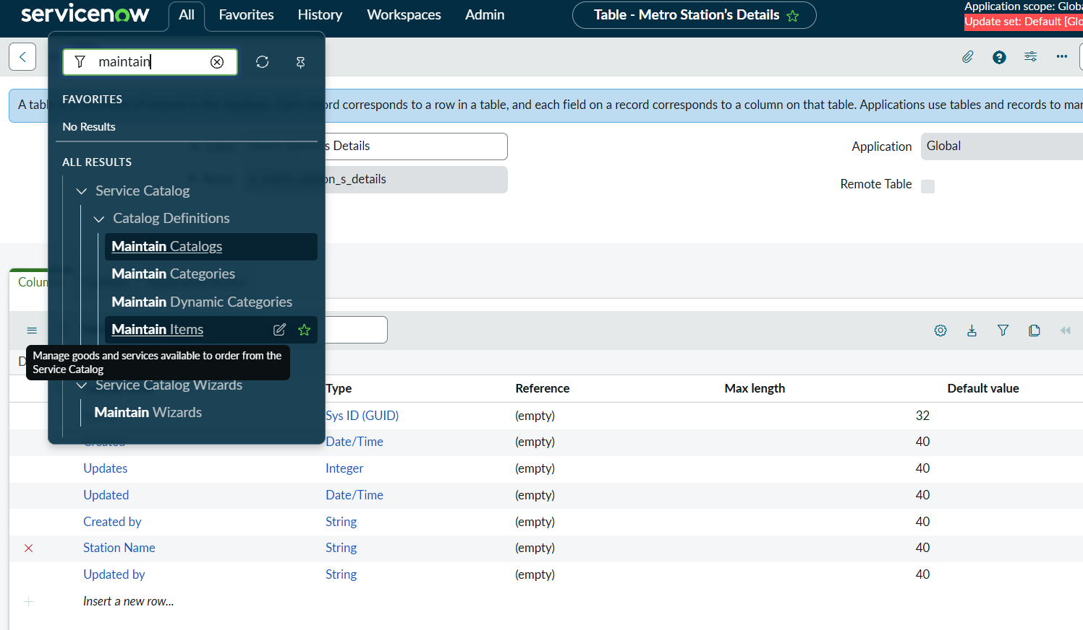
Figure 1: Opening Service Catalog > Maintain Items from the Application Navigator
Property | Value
Name | Book A Metro Ticket
Catalog | Service Catalog
Category | Services
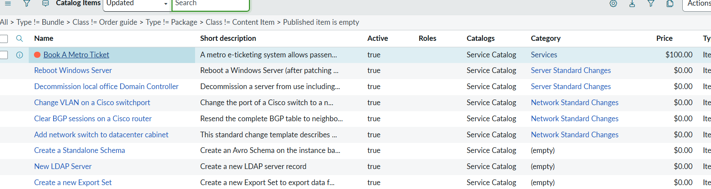
Figure 2: Book A Metro Ticket in the Catalog Items list (Service Catalog, category Services)

2.2 Activity 2: Variables Configuration
- Open the catalog item that was just created.
- Scroll down to the Variables related list and click New to create the form fields.
- Select the variable type (single line text, multi line text, reference, choices, etc.) as per the requirement.
- Fill in the variable details as described below.
- Click Save or Submit.

Field | Description
Catalog item | Book A Metro Ticket
Order | Display order of the variable on the form (100, 200, 300, and so on).
Question | The variable label shown to the user.
Name | The variable name, used for scripting.
Tooltip | Text that appears when the cursor is hovered over the field.
Example text | Suggests what needs to be entered in the field.
Mandatory, Read-only | Configured on demand.
Auto populate | Select the dependent variable and apply dot-walking to get the selected value.

2.3 Variables to Create
S.No | Variable / Question | Variable Type | Choices / References
1 | Starting From | Reference | Metro Station's Details (u_metro_station_s_details)
2 | Going To | Reference | Metro Station's Details (u_metro_station_s_details)
3 | Type of Journey | Multiple Choice | Single journey (1), Return journey (2)
4 | No of Passengers | Select Box | 1, 2, 3, 4
5 | Amount for single journey | Single Line Text | -
6 | Amount including return | Single Line Text | -
7 | Mode of Payment | Multiple Choice | UPI, Card, Others
8 | Enter payment mode | Single Line Text | -
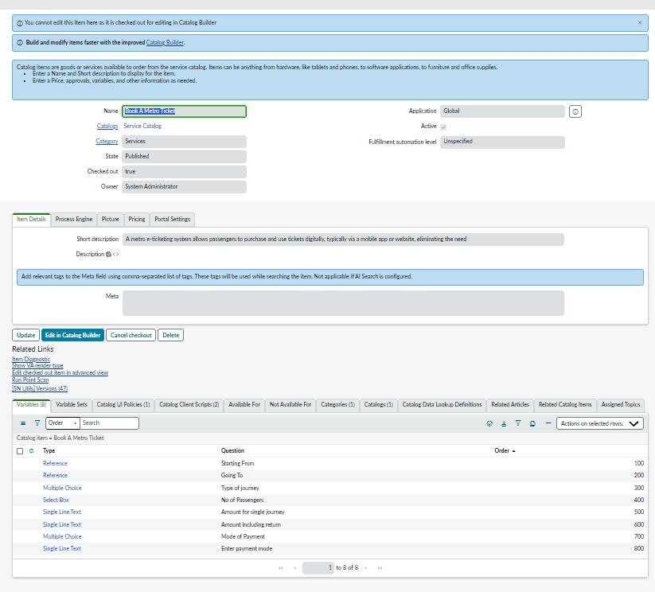
Figure 3: Book A Metro Ticket catalog item with its 8 variables

The scripts in Phase 2 refer to these variables by their names: starting_from, going_to, type_of_journey, amount_for_single_journey, and amount_including_return. The variable names and back-end values must match those used in the scripts.

3. Widgets

3.1 Creation of Widgets in the Portal
A Service Portal widget was created to display the QR code ticket to the user. The QR Generation client script (Phase 2) calls this widget by its ID.
- Navigate to the Application Navigator.
- Click All and search for Service Portal.
- Under Service Portal, select Widgets.
- Click New and fill in the widget details as shown below.
- Click Submit or Save.
- Copy and paste the HTML and server scripts given below.
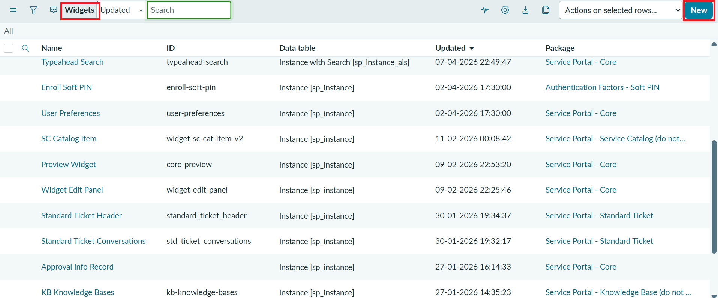
Figure 4: Service Portal Widgets list with the New button
Property | Value
Name | Metro QR Widget
ID | metro_qr_widget (called by the QR Generation script)
Description | Widget to display and manage functionalities

Note: check the field names while using these scripts. The widget receives the QR image URL as qr_url, which is passed from the QR Generation client script.

HTML Code
<div style="text-align:center; padding:25px; font-family:Arial, sans-serif;">
<h3>Your Metro Ticket QR Code</h3>
<img ng-src="{{data.qr_url}}" style="width:250px; height:250px; border:1px solid #ccc; padding:10px;" />
<p>Scan this QR code at the metro station gate</p>
</div>

Server Script
(function() {
data.qr_url = input ? input.qr_url : '';
})();

The server script reads qr_url from the widget input and stores it in data.qr_url. The HTML template then shows it as an image, with the message to scan the QR code at the metro station gate.

4. Navigation Flow
The booking flow is accessed and tested through the Service Portal, as described below.
- Log in to the ServiceNow PDI.
- Copy the instance domain, for example https://domain.service-now.com.
- Paste the URL in a new tab and add /sp at the end, for example https://domain.service-now.com/sp.
- Search for Book A Metro Ticket.
- Fill in the required details and click Submit.
- A new request is generated with a request number, and the details are shown on the Requested Item page.
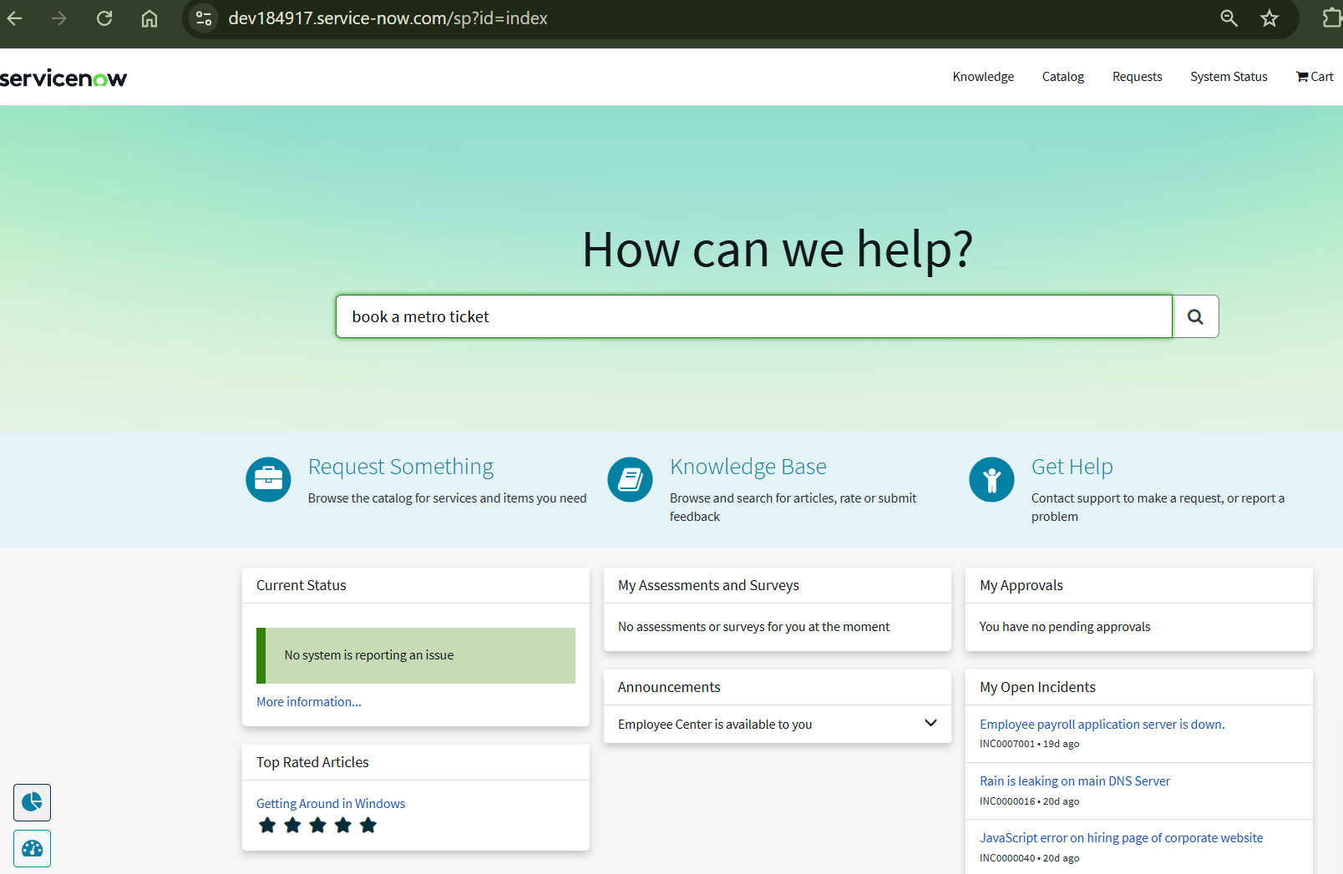
Figure 5: Service Portal home page with Book A Metro Ticket searched
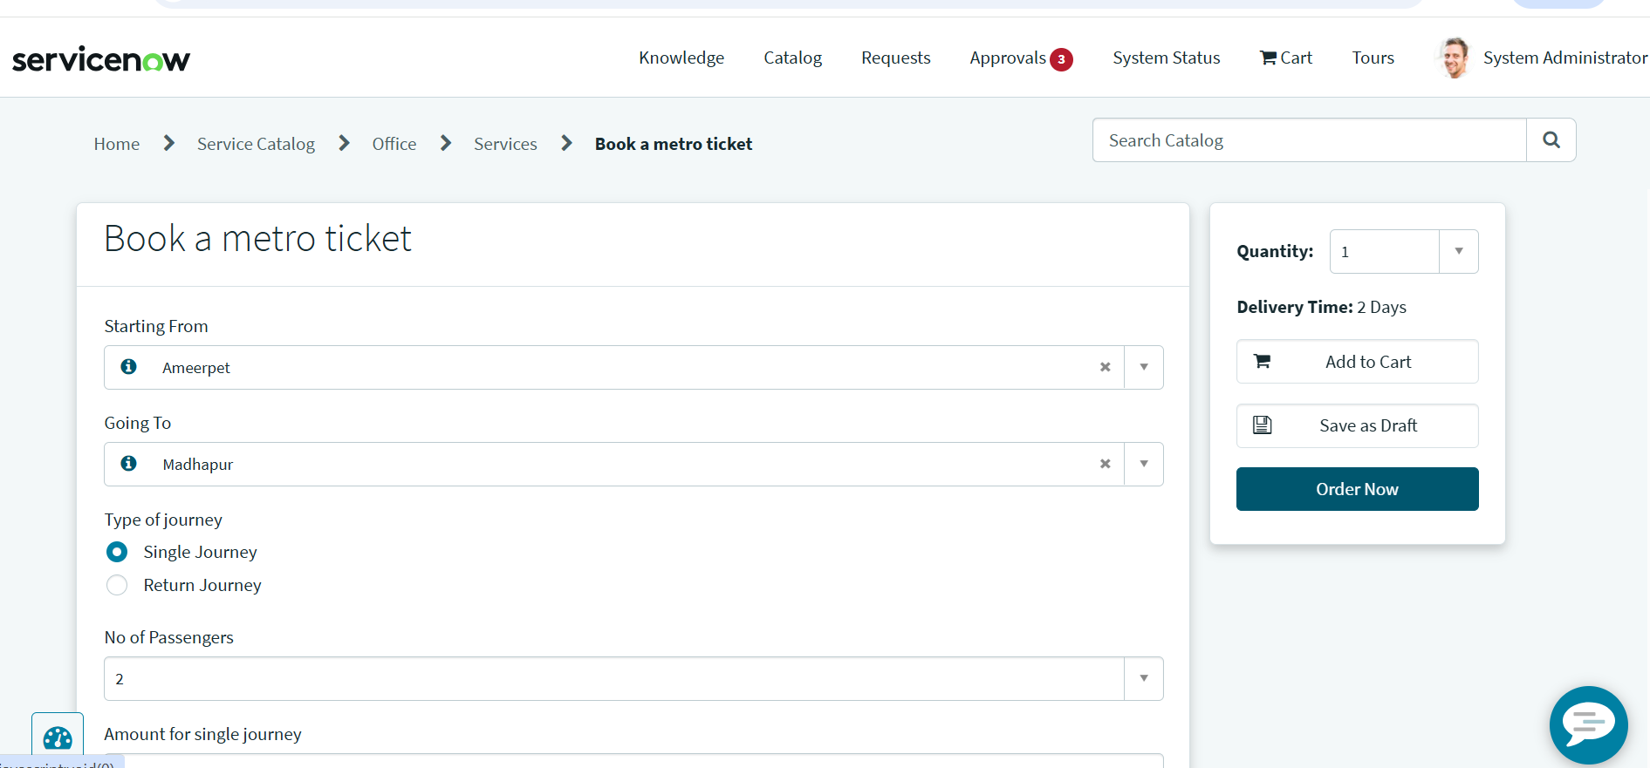
Figure 6: Book a metro ticket form with the stations, type of journey and number of passengers
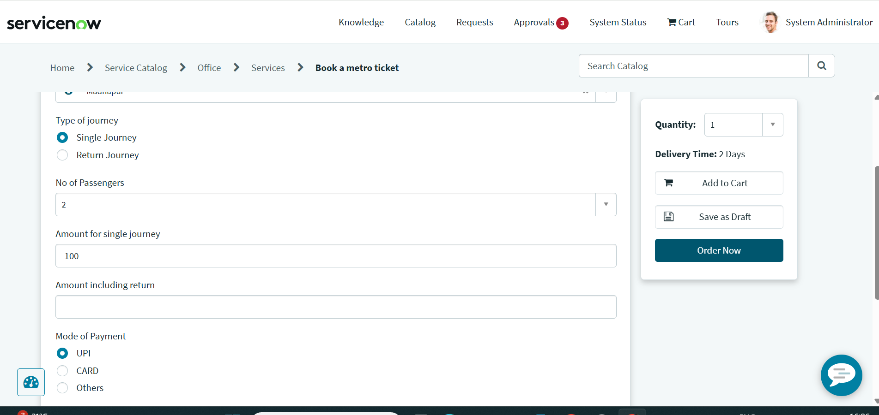
Figure 7: Amount fields and Mode of Payment options on the booking form

5. Summary
The Book A Metro Ticket catalog item was created in the Service Catalog under the Services category, and its eight variables were defined for the booking form. The Metro QR Widget (metro_qr_widget) was created in the Service Portal to display the QR code ticket. The navigation flow was then followed through the Service Portal (/sp) to search for the item, fill in the booking form and submit it.

